
Institute of Cultural Affairs
(ICA: Kenya)

The Institute of Cultural Affairs (ICA) Kenya is registered as an NGO with the National Coordination Board in the office of the President. ICA Kenya is also a statutory member of ICA International, a global community of non-profit organisations advancing human development worldwide. Why Culture? Culture is the shared understandings, values, patterns, symbols and stories that build community and provide a context for decisions - what needs to be re-empowered if a more sustainable society is to emerge from the present situation. ICA seeks to empower an authentic and sustainable transformation of individuals, communities and organizations, through methods and values.

ICA uses a participatory approach to community development that depends on facilitating people and communities to come together to achieve positive change using their own knowledge, skills and lived experience of the issues they encounter in their own lives.

This is a bottom-up approach that is inclusive, comprehensive, building upon the existing social capital within a community and relying on local engagement. Its focus is on making communities Self-reliant, Self-sufficient and Self-Confident.

With over 40 years of experience in global development, both rural and urban, the Institute has built partnerships with governments, the private sector and non-profits. It has been funded by the Ford Foundation, national governments, the European Union governments, UNDP, FAO, UNICEF and many local governments. It has Special Consultative Status with the United Nations Economic and Social Council (ECOSOC).

ICA specialises in the Technology of Participation (ToP), and schedules public courses on Group Facilitation Methods open to all. It provides in-house (tailor-made) consultancies, training and facilitation services, primarily to communities, the voluntary and public sectors. The intent is to contribute towards a culture of participation by developing the skills and knowledge to enable widespread understanding and effective use of facilitation methods and skills and to inform and encourage the behaviours and attitudes which recognise and value participation amongst the people who use, experience, commission and promote facilitation methods.

The following are courses which can be commissioned or arranged to achieve the above intent:

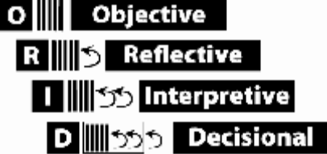
- ToP Focused Conversation method: uses a four-level sequence of questions that moves a group’s discussion from the objective information through their initial responses and interpretations to clear conclusions. It is known as the ORID method.

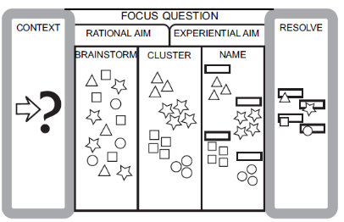
- The Consensus Workshop Method: uses a five-step process to build consensus about a complex topic. It begins with a focus question (Context), gets the group Brainstorming responses, helps the group organize the ideas into clusters, enables the group to identify the core idea in each cluster (Naming) and helps them determine the appropriate next steps (Resolve).

- ToP Action Planning workshop uses an eight series of steps that translates a project idea, strategy or task into a focused actionable timeline.

- Participatory Strategic Planning (PSP): tthrough this process a group develops their strategic actions and an action plan. It begins by creating a shared, positive vision of the group’s hopes and desired outcomes (Practical Vision), then look at the obstacles to the realization of that vision (Underlying Contradictions), identifies a range of possible actions to deal with these (Strategic Directions) and concludes with a calendar of accomplishments, assignments and specific next steps for implementing the plans (Focused Implementation).

For further information please contact:

Nathan Ambunya Andika,
Programme coordinator
Institute of Cultural Affairs Kenya (ICA: K)
Shalom House, Off Ngong Road
PO BOX 76622-00508
Nairobi, Kenya

Tel: +254 7222791328/ +254 100229674
E-Mail: icakenya1@gmail.com

